Pre-Reading

Confrontation
The continuous is introduced in this lesson. When the speaker finds his father, his father is 正在 (zheng4zai4) doing something. The first character 正 literally means “just” as in “just then” and 在 means “at, at the moment” so 正在 means “just at that moment.” In Chinese, the present and past continuous can be formed by using either 正在, or the less formal在. Following the continuous 正在 is the character 拿 (na2), which means to grab or take. This character is formed with a 合, which means join or fit, on top and a 手, or hand, on the bottom. Thus, when something fits in your hand, you can take or grab it.
After 拿 is the character 着, which similar to 正在 is used to show that an action is in progress. Unlike 正在, which is used in front of a verb, 着 always follows the verb. You can use either 正在，着, or both to describe an action in progress. So you could say 他看着我, which simply means “He is looking at me” or you could say 他正在看我 which would have a similar meaning. The speaker tells his father 别 steal. 别 is similar to 不, in that it negates verbs. Here it means "don’t" For example, your friend may say 你别喝酒，“don't drink alcohol.” In contrast if you say 你不喝酒 it would mean “You don’t usually drink alcohol. 不 is usually used to negate habitual actions or current actions. Where as 别 is usually used as a demand. Shortly after 别 we see 没 (mei2) this is also a negation word but is generally used for past tense so if I said 我没喝酒 it means “I didn’t drink alcohol.” However 没 also combines with 有 to mean I don’t have. The following character 怎 means how, and is almost always followed by 么. For example, you can say 你怎么来的 (ni3zen3me lai2de) or 你怎么认识他 (ni3zen3me ren4shi ta1), which means “how did you come” and “how do you know him.” Here the 怎么is followed by 会 (hui4) which means “can.” However 会 should be compared with 能 (neng2) which also means “can.” 会 has the implication of being able (to do something) as a result of an acquired skill, whereas 能 conveys physical ability, or ability under the circumstances at the time. So, for example 你__不__骑自行车？ (Can you ride a bicycle?), most people have the physical ability to do so (in other words, having two arms and two legs), but the determining factor in whether they can ride or not is whether they have learnt the skill of riding a bike, so here the most appropriate answer would be 会. That is not to say, however, that 能 is not a possible answer. If someone has just lost a leg (for example due to an accident), you may very well ask 你能不能骑自行车？ Next is the word 觉得. The character 觉 can be read as both (jue2) and (jiao4) here is it (jue2) and it means to think or feel. However, when used with the character 睡, as in 睡觉, it is pronounced (jiao4) and it means to sleep. 莫名其妙 (mo4ming2qi2miao4)is the first chengyu that you encounter. It means out of the blue or unfathomable mystery/baffled. The last character is 啊(a1) which expresses surprise.
Story Character Count = 77

Vocabulary/Writing

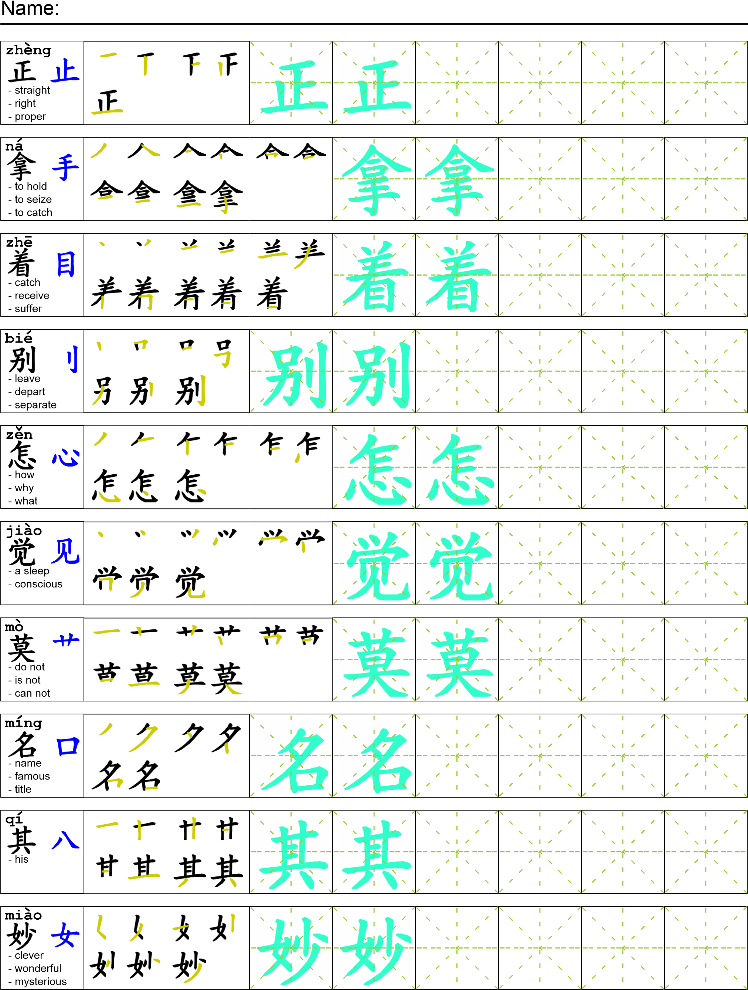
Reading

找到我爸爸的时候他正在拿着一本书。我说“爸爸别偷东西了！”爸爸看着我说“我没有偷，你怎么会觉得我偷东西？”我妹妹说：“爸爸我们知道是你偷了学校用品”。爸爸莫名其妙地回答“我没有啊！”

Task Completion

Once all tasks are complete turn the assignment in to collect the points for the project.
Task 1: Trace the vocabulary

Task 2: Answer Comprehension Questions

Task 3: Write the Pinyin for the Reading

Task 4: Translate the Reading into English

Task 5: Record yourself reading the passage twice

Comprehension Questions
- What are two ways to indicate present continuous in Chinese? __________________________
- What happened when the writer accused his father of stealing? _________________________
- What is the difference between 能and 会？____________________________________________________________________________________________________________________________________________________________________

